**Version Control Software Evaluation Report**

**Math for Games**

**Domenico Mandica**

**06/04/21**

**Version Control Software**

The version control software I decided to use was Git. The client program I decided to use was GitHub official app, GitHub Desktop.

The reason I decided to use GithHub’s client is that Source Tree giving me a hard time. For some reason, I could not log in with my GitHub account; Most likely due to two-factor authentication. Then I had other issues with Source Tree such as an option box repeatedly opening every time, I did something.

**Performance**

GitHub desktop was extremely easy and simple to use. The reason it was so simple is due to the bare bone GUI, which makes it less intimidating to use and therefore making it easier to use.

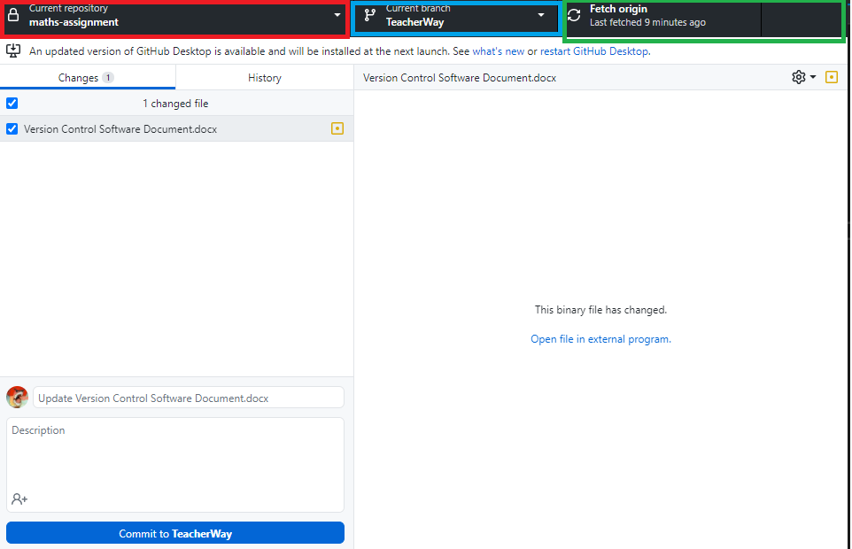

**Model 1.0 – GitHub Desktop GUI**

Model 1.0 shows that GitHub Desktop only has about 4 buttons, which makes it very simple. The commit button is the large blue button on the bottom, which lets the user create a commit for the changed files, with a name and description of the change.

The top left button allows the user to change the currently viewed repository. It also allows the user to clone repositories directly from their GitHub account. This saves more time than having to find the repository, copy the link, and then paste it.

The button next to that is the branch button. This button allows the user to both create new branches as well as change the currently viewed branch. I found this button very effective because at one point my main project was not working properly; So, I created a new branch then programmed more according to Carmine’s lectures.

Finally, the Fetch Origin button, which also changes to a pull button when the local machines files do not match the repository being viewed.

Compared to Source Tree, GitHub Desktop performs immensely better. Connecting my GitHub account was also very easy, when compared to the hassle I had with Source Tree.

The overall layout on GitHub Desktop is just better than Source Tree. The reason for this is because Source Tree is just cluttered with a lot of buttons which serve a purpose but takes time to get used to. GitHub desktop is easy to pick up straight out the box.

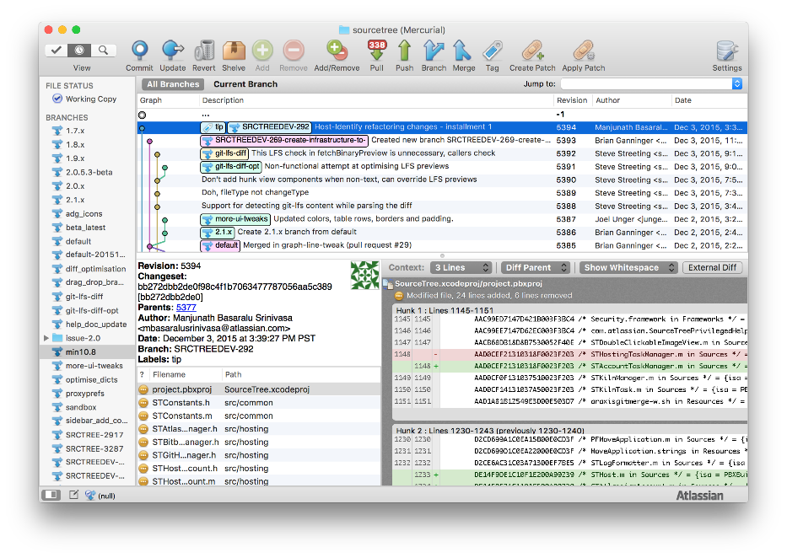

**Model 2.0 – Source Trees’ overwhelming GUI, note the overwhelming number of buttons allowing more flexibility, but making the app more cluttered.**

**Environmental Considerations**

If an organization would want to use GitHub, they would have to bear in mind that only 1gb of space can be used for the free version. For a game project, this may prove to be too small after some time. There are ways around this, such as using a modified gitignore, or even separating all visuals/graphics from the main repository.

If an organization were to have their own self-hosted version control server, they would have to be willing to spend quite a bit of money. According to an article in 2018, the average monthly cost of a cloud server is around $315 per month whilst an on the premise dedicated server averaged about $1,400. These averages also included the cost of scaling needs and an indirect cost of system administration staffing.

On top of all that, power costs to keep the server cooled will be a whole different story, since the costs will vary. On average, the power consumption would be an average of about $80 a month.

With this information, an organization may be spending up to $17,760 per year if they were to have a dedicated server. A cloud server on the other hand, is looking at about $4,740, which is a big difference.

This information is only based on averages from 3 years ago and may not be exactly the same as averages in 2021.

**Evaluation**

Overall, GitHub desktop is an excellent client for organizations to pick up. The main reason for this is that it is extremely simple and does not overwhelm the user with a clutter of buttons and options. Of course, with time, Source Tree might be more beneficial since it is more flexible, but this is under the assumption bugs do not occur such as the constant choice box.